Open Source Bus Tracking User Guide

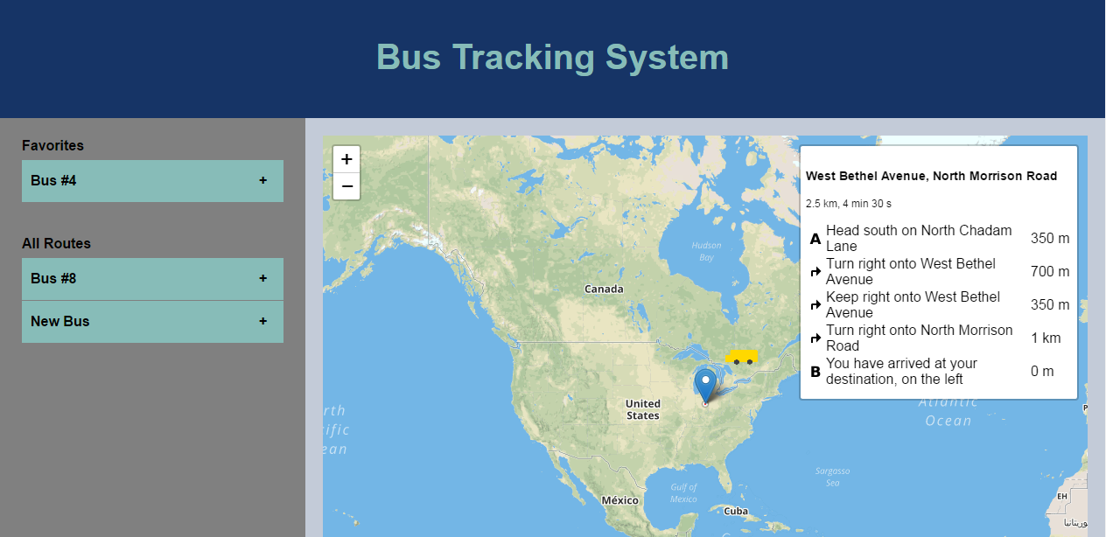

Thank you for using our Open Source Bus Tracker. This guide will help you understand how to use the application if you are unfamiliar with the format. This application is designed to provide a low cost option for tracking busses or other vehicles that people or organizations may be unable to afford the more expensive options for. This tracker was created by Cody Johnson, Rebecca Lawrence, and Darcy Steele.

|  |  |
| --- | --- |
|  | This is the title of your bus tracking application. If you are an administrator and would like to learn about editing this consult the Admin Guide. |

|  |  |
| --- | --- |
|  | This is the map view. This allows you to see where the bus you are tracking is currently located and provides directions if you need to know the route the bus is taking. It also allows you to zoom in and out. |

|  |  |
| --- | --- |
|  | This is the bus marker. It shows you the position of the bus. If you are an admin and want to know more about the marker and changing it to a different image, refer to the Admin Guide. |

|  |  |
| --- | --- |
|  | This is the sidebar that houses all of the information you will need to know about the busses. It shows the bus name and if you click the plus sign that is pictured on each individual tab in the image to the left, you will be able to see the bus’ estimated time of arrival. There is also the option of adding favorite busses to a list at the top of the sidebar so they are always easily accessible. If you are an administrator and would like to know more about how to change the bus list or remove features, refer to our Admin Guide. |